School Banking program communication templates for your school.

1. “Get involved in the School Banking program.”
Use this template to provide information about the School Banking program.

2. “School Banking program Account Opening Day.”
Use this template to promote the School Banking program and your upcoming Account Opening Day.

3. “Join the Dollarmites on an Outback savings adventure with School Banking!”
Use this template to promote the new 2016 School Banking program theme, reward items and Australia Zoo competition.

4. “New School Banking rewards now available!”
Use this template to promote the new Term 3 reward items.

5. “<Character name> is coming to <school name>!”
Use this template to promote an upcoming day where one of the Dollarmites characters will be making a visit to your school.

6. “School Banking day is <day>.”
Use this template to remind parents/guardians and students what day School Banking day is at your school.

7. “Congratulations to our School Banking savers!”
Use this template to encourage eligible students to redeem for their reward item on the next School Banking day or at a rewards redemption day.

8. “Calling for volunteers – we need your help!”
Use this template to help you find a replacement (or additional) School Banking Co-ordinator to support the School Banking program at your school.

9. “Thank you to our School Banking Co-ordinator.”
Use this template to help you thank a departing Co-ordinator for their support and introduce your new School Banking Co-ordinator to the school.

10. “<$xxx> raised through School Banking!”
Use this template to help you share your fundraising efforts through the School Banking program and thank parents and students for their support.

Get involved in the School Banking program.

<School name> is excited to offer the Commonwealth Bank School Banking program to all students.

The School Banking program provides children with an opportunity to deposit money into their Commonwealth Bank Youthsaver account at school each week. The program is about how often your child makes deposits, not how much they deposit.

To encourage regular savings behaviour the program offers an exciting Rewards Program. Every deposit earns your child a silver Dollarmites token, and once they’ve collected 10 tokens they can redeem them for a reward.
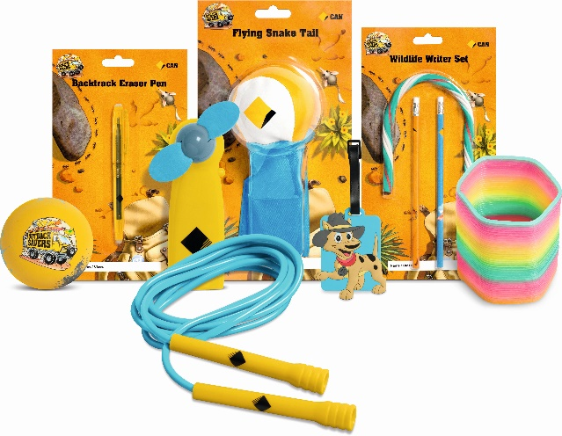
The rewards available during 2016 are:
- Flying Snake Tail
- Wildlife Writer Set
- Mud Splat Handball
- Outback Pat Bag Tag
- Backtrack Eraser Pen
- Jump and Skip Rope
- Bush Fly Fan
- Wriggly Glow Worm
School Banking is also a great fundraiser for our school. Our school receives $5 when a student makes their first ever School Banking deposit and 5% on every deposit made through the school (to a maximum of $10 per individual deposit).

Getting involved in School Banking is easy!

All you need to get involved in the School Banking program is a Commonwealth Bank Youthsaver account. To open an account for your child, you can visit your local branch. All you need to bring is your current personal identification as well as your child’s birth certificate. If you are an existing Commonwealth Bank customer and have NetBank, you can open an account for your child online.

If your child has an existing Commonwealth Bank Youthsaver account they can start banking straight away. They just need to bring their deposit in every week on School Banking day using their Dollarmites deposit wallet.

School Banking day is <day>. Each week you need to <insert process for handing in book>.

If you would like to know more about the School Banking program, please ask for a 2016 School Banking program parent pack from the school office.

School Banking program Account Opening Day.

<School name> is excited to offer the Commonwealth Bank School Banking program to all students.

The School Banking program provides children with an opportunity to deposit money into their Commonwealth Bank Youthsaver account at school each week. The program is about how often your child makes deposits, not how much they deposit.

To encourage regular savings behaviour the program offers an exciting Rewards Program. Every deposit earns your child a Dollarmites token, and once they’ve collected 10 tokens they can redeem them for a reward.
The rewards available during 2016 are:

- Flying Snake Tail
- Wildlife Writer Set
- Mud Splat Handball
- Outback Pat Bag Tag
- Backtrack Eraser Pen
- Jump and Skip Rope
- Bush Fly Fan
- Wriggly Glow Worm

School Banking day is <day>. Each week you need to <insert process for handing in book>.

We will be holding an Account Opening Day at our school:

Time: <time>
Date: <date>
Location: <location>

If you are interested in opening a Commonwealth Bank Youthsaver account for your child please bring along your current driver’s licence or another form of photographic identification.

Alternatively, you can open an account at your local branch. All you need to bring is your current personal identification as well as your child’s birth certificate. If you are an existing Commonwealth Bank customer and have NetBank, you can open an account for your child online.

If you would like to know more about School Banking, please ask for a 2016 School Banking program parent pack from the school office.

Join the Dollarmites on an Outback savings adventure with School Banking!

Every year the School Banking program launches a new savings theme and eight new exclusive School Banking reward items.

This year’s program is themed the Outback Savers and School Banking is taking students on a wild adventure through the Canyon of Savings, where they’ll learn to master smart savings habits.
There are eight new reward items for 2016 available from the Outback Savers range:

- Flying Snake Tail
- Wildlife Writer Set
- Mud Splat Handball
- Outback Pat Bag Tag
- Backtrack Eraser Pen
- Jump and Skip Rope
- Bush Fly Fan
- Wriggly Glow Worm

Win a wildlife family adventure holiday to Australia Zoo!

This year School Banking is giving students the chance to win a family trip for up to two adults and three children to explore Australia Zoo and meet Bindi and Robert Irwin.

Students who make 15 or more School Banking deposits by the end of Term 3, 2016 will be automatically entered into the draw. This is another great way to motivate students to save regularly and reach their savings goals.

If you would like to know more about School Banking, please ask for a 2016 School Banking program parent pack from the school office.

New School Banking rewards now available!

Exciting new Term 3 rewards with an Outback Savers theme are now available,
while stocks last!

Backtrack Eraser Pen | Jump and Skip Rope
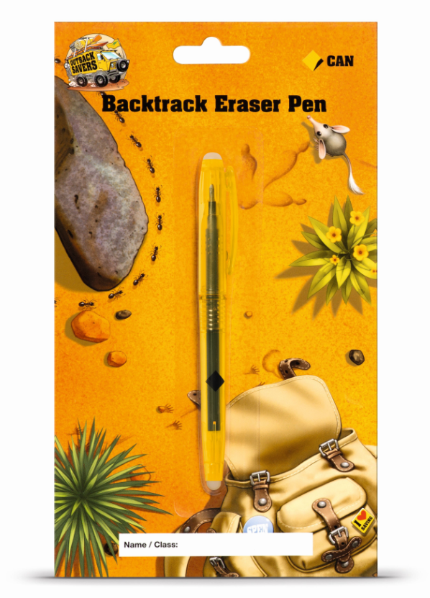

For every deposit made at school, no matter how big or small, students will receive a silver Dollarmites token. Once students have individually collected 10 tokens they can redeem them for exclusive School Banking reward items in recognition of their regular savings habits. There are two new items realeased each term so be sure to keep an eye out for them!

Thank you for supporting the School Banking program and remember, School Banking day is every <day>.

<Character name> is coming to <school name>!
A special Dollarmites visitor is coming to school to <insert activity e.g. talk to us about the School Banking program or collect School Banking books>.

<Character name> is excited to see you all on <date>.

Remember, School Banking day is every <day>.

School Banking day is <day>.
Remember, <day> is School Banking day and students should bring in their weekly deposit.

For every deposit made at school, no matter how big or small, students will receive a silver Dollarmites token. Once students have individually collected 10 tokens they can redeem them for an exclusive School Banking reward item in recognition of their regular savings habits.

School Banking is also a great fundraiser for our school, raising 5% on every deposit made through the school (to a maximum of $10 per individual deposit).
If your child has lost their book, they can bring their money to school in a sealed envelope with a note on the next School Banking day. We will issue them with a replacement.

Thank you for supporting the School Banking program at <school name>. We would also like to thank the wonderful parents who volunteer as our School Banking Co-ordinators and process our banking every week.

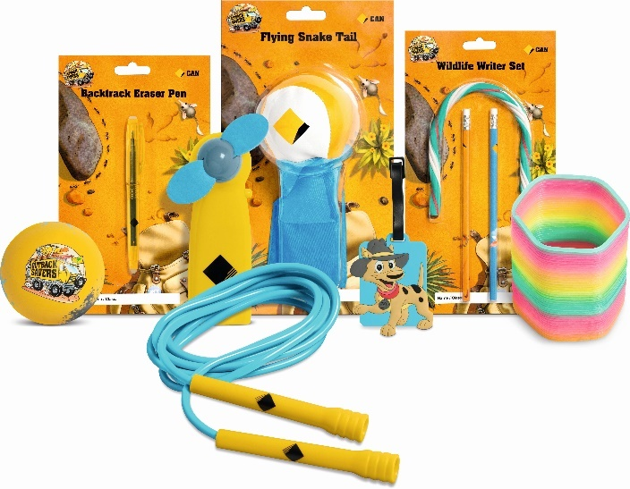
Congratulations to our School Banking savers!
Congratulations to our School Banking students who have earned 10 silver Dollarmites tokens. They are now eligible to redeem these tokens for an exclusive School Banking reward item!

Eligible students can redeem for a reward by bringing their completed rewards card to school, along with their 10 tokens, on <insert day e.g. the next School Banking day or a specific rewards redemption date>.

Keep up the great work and remember, School Banking day is every <day>.

Calling for volunteers – we need your help!

Our students really enjoy participating in the Commonwealth Bank School Banking program and to keep this program running we need your help.

The program requires a volunteer School Banking Co-ordinator to facilitate the banking and distribution of School Banking rewards. This only takes a small amount of your time one day a week and the Commonwealth Bank will provide support in how to run the program. Your help with the program will greatly benefit students as they develop vital saving skills and also help our school with fundraising.

Currently, School Banking day is <day>.

If you are interested in volunteering for this great program, please fill in the tear off section below and return it to <return details>.

Yes, I would like to help with School Banking!
Name: _____________________________________
Phone: _____________________________________
Email: ______________________________________
Availability: __________________________________

Thank you to our School Banking Co-ordinator.
We would like to thank <Co-ordinator name> who has volunteered as our School Banking Co-ordinator since <date>. <Name> will be finishing up as our Co-ordinator on <date>. We would also like to welcome <name> as our new School Banking Co-ordinator!

Our School Banking volunteers are vital in helping teach students the importance of saving regularly.

<$xxx> raised through School Banking!
Thanks to the fantastic efforts of our students we have raised <$xxxx> for our school through School Banking commissions in <term 1,2 etc>. Our school receives $5 when a student makes their first ever School Banking deposit and 5% on every deposit made through the school (to a maximum of $10 per individual deposit).

These funds will go towards <insert activity/item>.

Saving regularly is an important habit to get into, whether you're saving a little or a lot. Keep up the great work and remember, School Banking day is every <day>.

