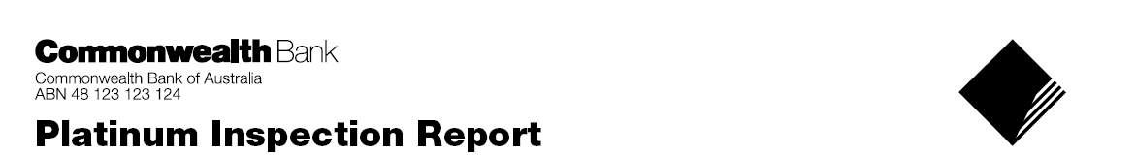
Asset Finance Documentation Request

 | Submission Details
 | Date |  | Broker Name
 | Email Address for document delivery |  | Broker Firm

 | Contract Details
 | Customer Name |  | Facility, please indicate
 |  |  | Equipment Loan (also known as Chattel Mortgage) / Hire Purchase / Novated Lease / Finance Lease
 | Finance amount |  | Advance/Arrears
 | $ |  | Advance Arrears
 | Term (months), please indicate |  | Balloon/Residual (incl. GST)
 | 12 / 24 / 36 / 48 / 60 |  | $
 | Bank Rate (%) |  | Brokerage (incl. GST)
 | $ |  | $
 | Commonwealth Bank/CBFC Payout amount |  | Contract Number of contract to be paid out
 | $
 | Invoice attached
Yes / No
If the finance facility is a Hire Purchase or a Lease Agreement, the dealership Tax Invoice is to be made out to Commonwealth Bank of Australia, for delivery to the client.
If the facility is an Equipment Loan, the dealership Tax Invoice is to be made out to the client.
 | Additional Comments
PLEASE FAX ALL DOCUMENT REQUESTS TO 1300 781 976 OR EMAIL TO afbroker@cba.com.au

IN ALL CASES, PLEASE USE THIS FORM, AND ATTACH THE DEALERSHIP TAX INVOICE

PLEASE NOTE THAT WE RESERVE THE RIGHT TO CHARGE FOR ALL RE- DOCUMENTATION REQUESTS

